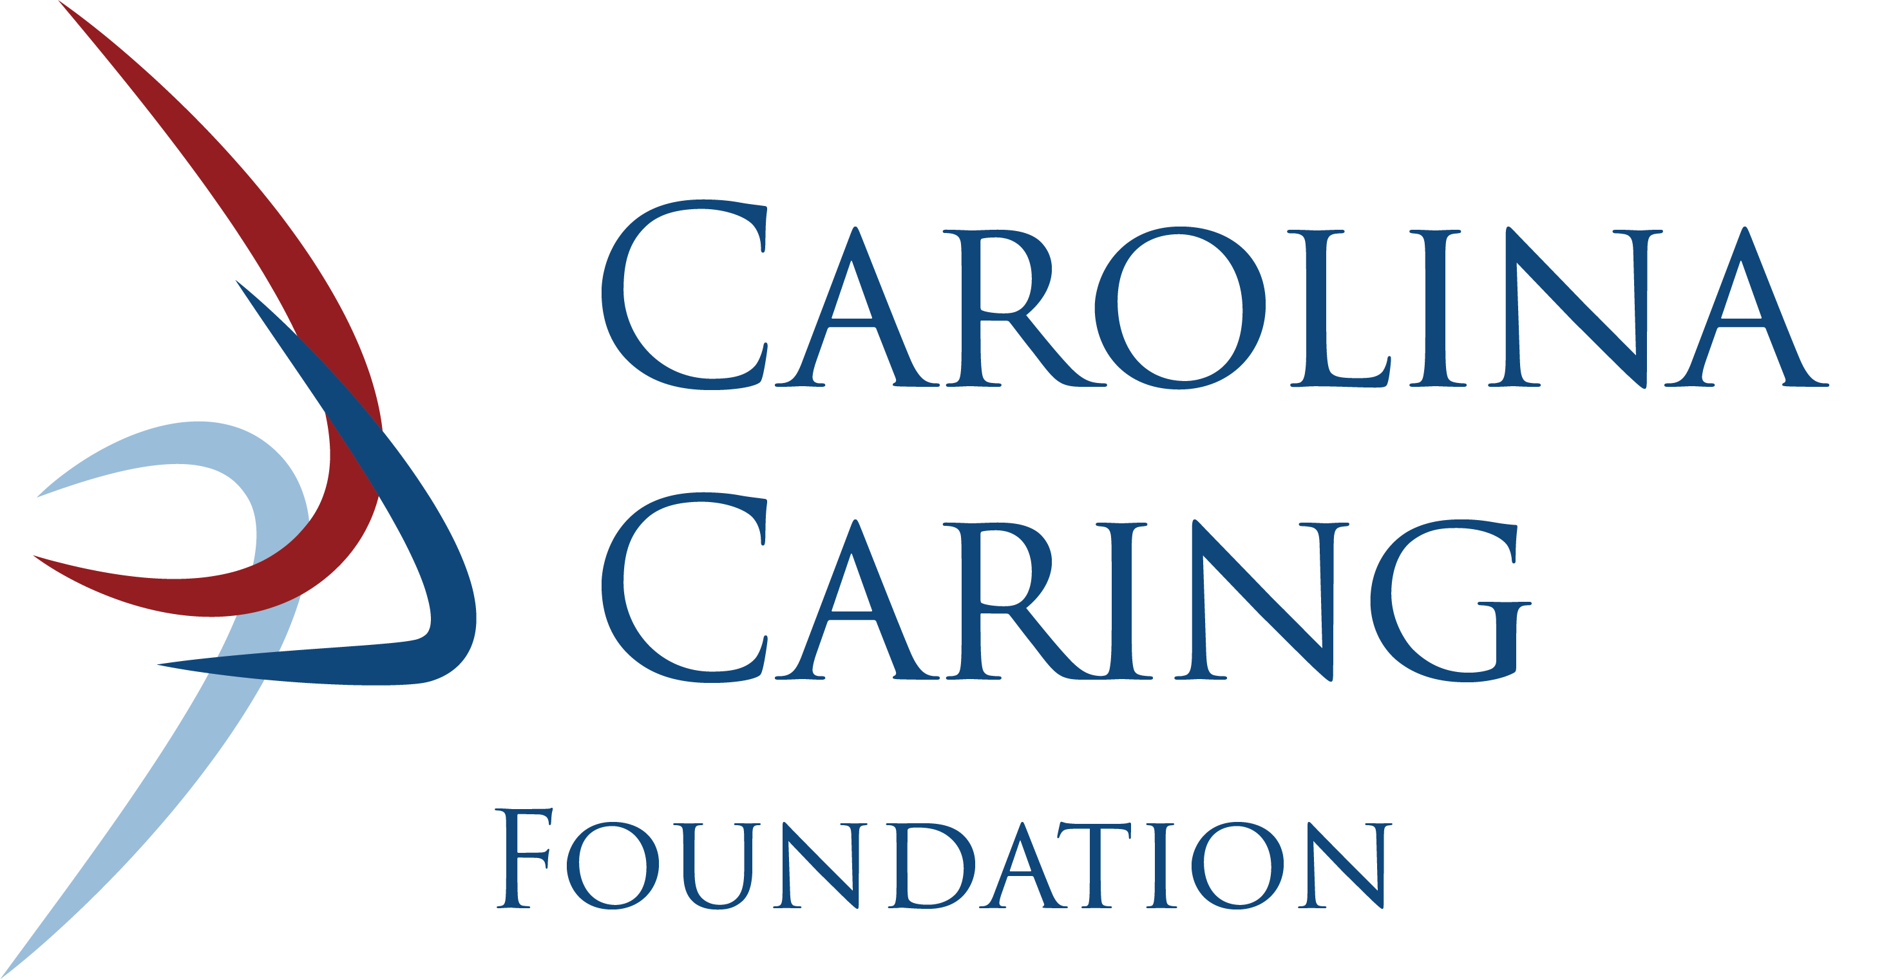

Ways to Leave a Legacy

Planning Your Gift

Fulfill a goal. Make a difference. Leave a legacy.

Discover the perfect balance of your personal financial goals and your charitable interests. You may realize significant tax benefits through gift planning while providing for a future donation. For more information about planning your gift, or to share that you have already included Carolina Caring Foundation in your will or estate plan, please contact Lorissa Vines at 828.466.0466 ext. 2143.

Legacy donors are invited to join our Circle of Life Society.

Bequests

One of the easiest ways to benefit Carolina Caring Foundation is to include a bequest in your will. Bequests provide you flexibility in making your estate plans and are a very effective way to accomplish many goals. There are several ways to make distributions in your will. Consult your attorney for advice and assistance in preparing any legal documents. The following language may assist you:

- Percentage of Estate: Allows for flexibility and changes in estate assets over time. “I give, devise, and bequeath to Carolina Caring Foundation _____% of my estate.”

- Specific Dollar Amount: Allows you to reach a specific gift level. “I give, devise and bequeath to Carolina Caring Foundation the amount of $________.”

- Specific Property: Identifies specific property or items you wish to give: "I give, devise, and bequeath to Carolina Caring Foundation the following property ________."
*Gifts of real and personal property must be approved by the Board of Directors.

- Residuary Estate: Whatever is left after other bequests have been granted. “I give, devise and bequeath to Carolina Caring Foundation the remainder of my estate, including real and personal property, after all specific requests have been distributed.”
*Gifts of real and personal property must be approved by the Board of Directors.

Beneficiary Designations

Life Insurance
Life insurance can be used to make a charitable gift by naming Carolina Caring Foundation as the owner and beneficiary of a life insurance policy. Such a gift provides you with a charitable income tax deduction equal to the current value of the policy or net premium payments, whichever is less. It is also possible to purchase a new policy naming Carolina Caring Foundation as owner and beneficiary.

Retirement Funds
A gift of a qualified retirement plan asset such as a 401(k), 403(b), IRA, Keogh or pension plan is another way to benefit Carolina Caring Foundation and enjoy significant tax savings. Donors maintain complete control over their retirement funds while living, but at their death, the balance remaining in their funds becomes the property of Carolina Caring Foundation free from both estate and income taxes.

Donor Advised Funds

Ensure that the assets in your philanthropic account continue to fulfill your charitable mission even after your lifetime by naming Carolina Caring Foundation in your succession plan through creating an endowment or designating a specific gift.

Trusts & Life Income Gifts

These gifts should always be made in consultation with your attorney and/or financial advisor.

- The Charitable Remainder Unitrust is an irrevocable transfer of property to a trustee that provides both a lifetime income and a charitable income tax deduction. Income is a predetermined percentage of the annual fair market value of the trust. Additional contributions can be made to a unitrust. As the trust’s assets increase, so does the payment to the donor.

- The Charitable Remainder Annuity Trust pays a fixed, guaranteed dollar amount, regardless of the trust’s investment performance. The income rate is established at the time the trust is funded. No additional gifts can be made to an annuity trust.

- The Charitable Lead Trust is created by transferring ownership of assets (cash, appreciated stock, real estate, etc. into an irrevocable charitable trust. Income is paid to Carolina Caring Foundation for a period of years chosen by the donor (up to 20 years) at which time trust assets are returned to the donor or other named chosen beneficiaries.

Carolina Caring Foundation
Tax ID #75-3140786
3975 Robinson Road Newton, NC 28658
CAROLINACARING.ORG
828.466.0466

